VJWTSS08190012

CODE CAMP DAY 1

Program :1 Write a c program to read a string and print the number of words and characters in the string.

Ans ;

#include <stdio.h>

#include <string.h>

main()

{

char str[20],*p;

int i=0, word=0, chr=0;

printf("\nEnter Your String: ");

gets(str);

p=str;

while (*p != '\0')

{

if (*p== ' ')

{

word++;

chr++;

}

else

chr++;

*p++;

}

printf("\nNumber of characters: %d", chr);

printf("\nNumber of words: %d", word+1);

}

Output :

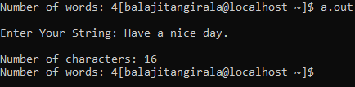

Program :2 a)without predefined functions:

Ans :

#include<stdio.h>

int main()

{

char str[80], search[10];

int count1 = 0, count2 = 0, i, j, flag;

printf("Enter a string:");

gets(str);

printf("Enter search substring:");

gets(search);

while (str[count1] != '\0')

count1++;

while (search[count2] != '\0')

count2++;

for (i = 0; i <= count1 - count2; i++)

{

for (j = i; j < i + count2; j++)

{

flag = 1;

if (str[j] != search[j - i])

{

flag = 0;

break;

}

}

if (flag == 1)

break;

}

if (flag == 1)

printf("string found in the main string\n");

else

printf("string not found in the main string\n");

return 0;

}

Output :

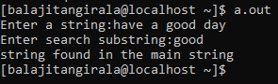

Program :2 b)with using predefined functions:

Ans :

#include <stdio.h>

#include <string.h>

int main()

{

char str[20],search[6];

char *ptr;

printf("enter a string\n");

gets(str);

printf("enter a substring\n");

gets(search);

ptr = strstr(str, search);

if (ptr != NULL)

{

printf("string found in the main string\n"); }

else

{

printf("String not found in the main string\n");

}

return 0;

}

Output :

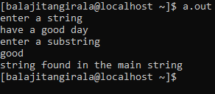

Program : 3 Write a C program to find sum of n elements entered by user. To perform this program, allocate memory dynamically using malloc() function.

Ans :

#include<stdio.h>

#include<stdlib.h>

int main()

{

int sum=0,i,n,*p;

printf("Enter number of elements:");

scanf("%d",&n);

p=(int *)malloc(n*(sizeof(int)));

printf("Enter elements of array:");

for(i=0;i<n;i++)

{

scanf("%d",(p+i));

}

for(i=0;i<n;i++)

sum+=*(p+i);

printf("sum of elements is :%d\n",sum);

free(p);

}

Output :

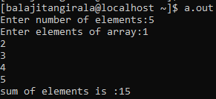

Program : 4 Find Largest Element Using Dynamic Memory Allocation - calloc()

Ans :

#include <stdio.h>

#include <stdlib.h>

int main()

{

int i, num;

float *data;

printf("Enter total number of elements(1 to 100): ");

scanf("%d", &num);

data = (float*) calloc(num, sizeof(float));

if(data == NULL)

{

printf("Error!!! memory not allocated.");

exit(0);

}

printf("\n");

for(i = 0; i < num; ++i)

{

printf("Enter Number %d: ", i + 1);

scanf("%f", data + i);

}

for(i = 1; i < num; ++i)

{

if(*data < *(data + i))

*data = *(data + i);

}

printf("Largest element = %f", *data);

return 0;}

Output : 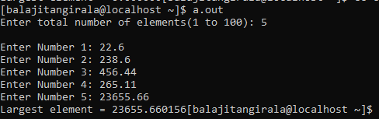

Program : 5 Create a dynamic list to store customer_no,customer_name and bill_amount and traverse it to show all the customers.

Ans :

Question is from out of syllabus.

Program :6 Create a function to search a customer in the above list based on the customer number passed as a parameter to the function.

Ans :

#include<stdio.h>

int linear(int *a,int n);

int main()

{

int p,n,cust_num[10]={11,12,13,14,15,16,17,18,19,20};

printf("Enter customer number:");

scanf("%d",&n);

p=linear(cust_num,n);

if(p!=10)

printf("customer num %d found at this position:%d\n",n,p+1);

else

printf("customer number is not found\n");

}

int linear(int *a,int n)

{

int i,k;

for(i=0;a[i];i++);

k=i;

for(i=0;i<=k;i++)

{

if(*(a+i)==n)

return i;

}

return 0;

}

Output :

